A000-Afr-Nigeria-Benin-Edo Peoples-Trumpet with bells-Bronze-19th c

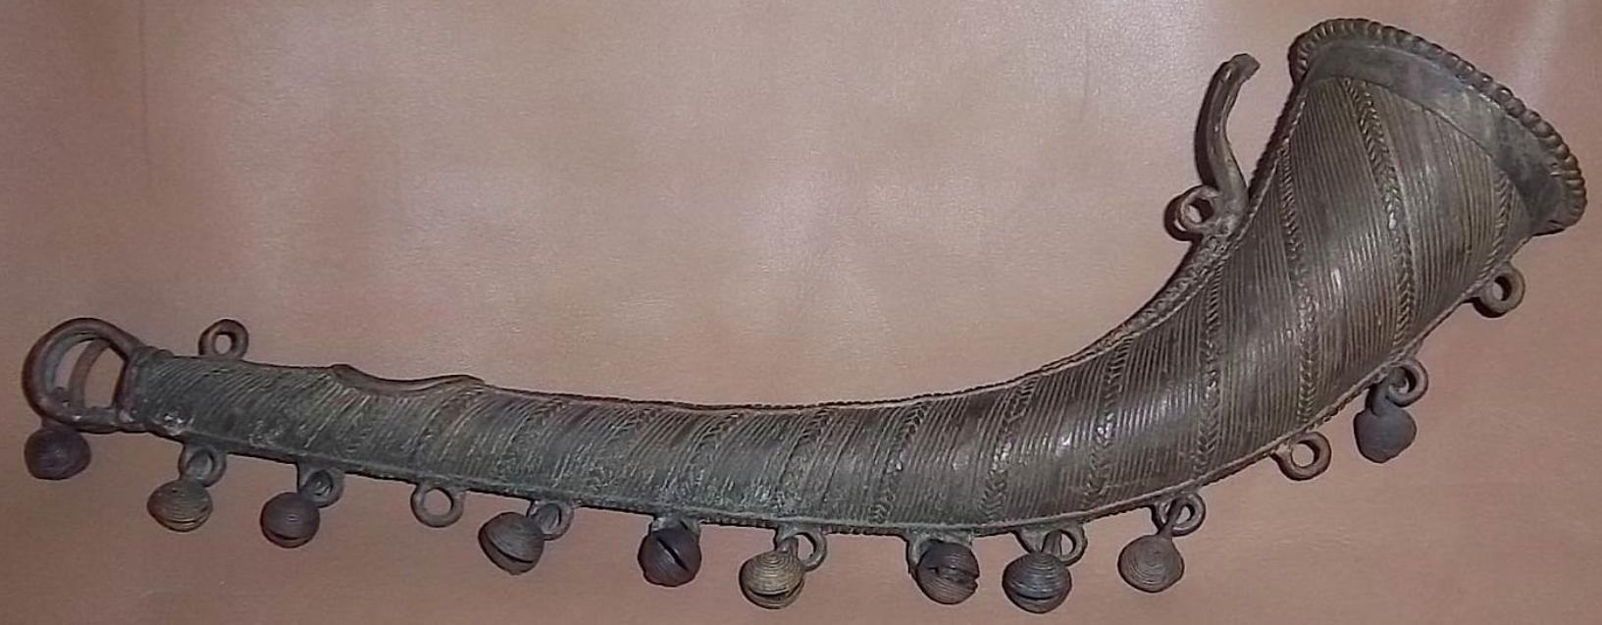

Fig. 1. Afr-Nigeria-Benin-Edo Peoples-Trumpet with bells-Bronze-19th c

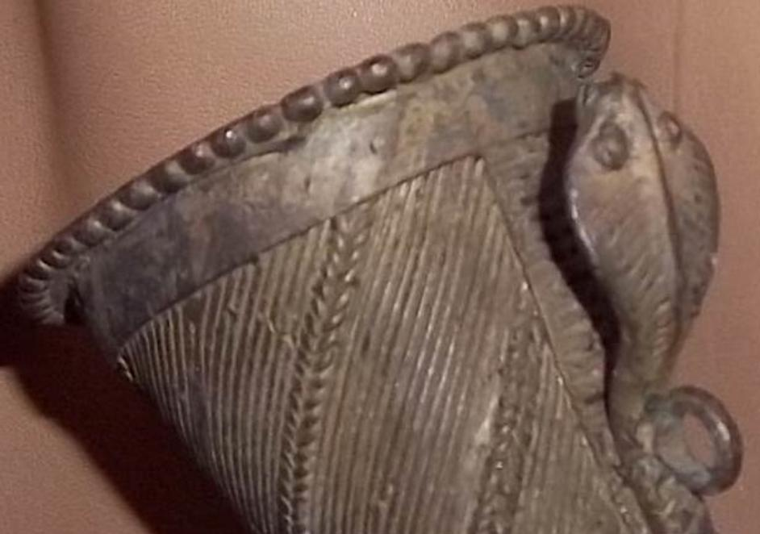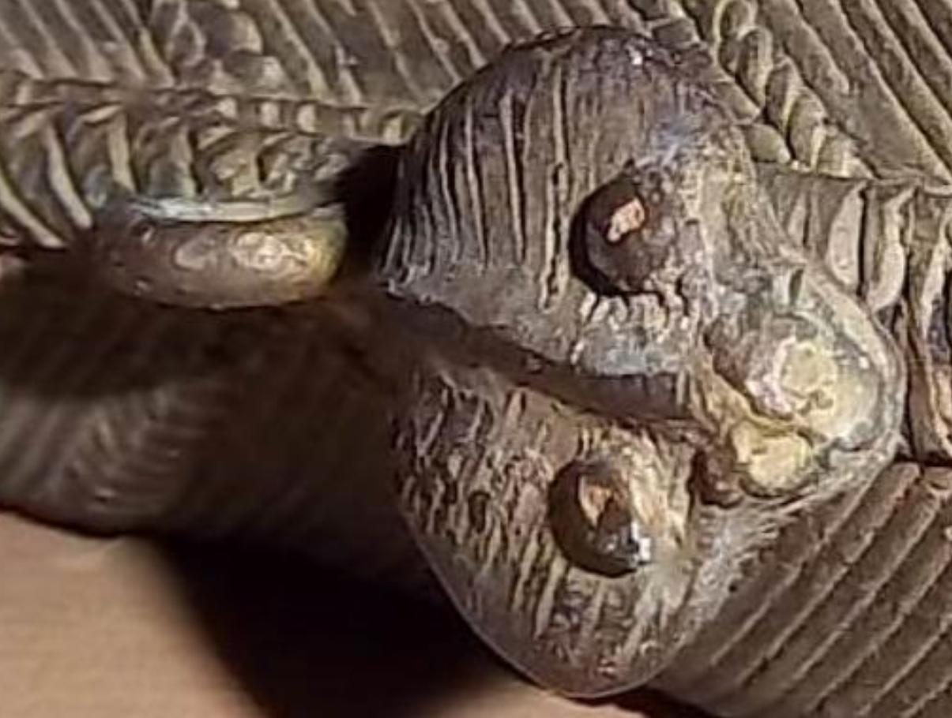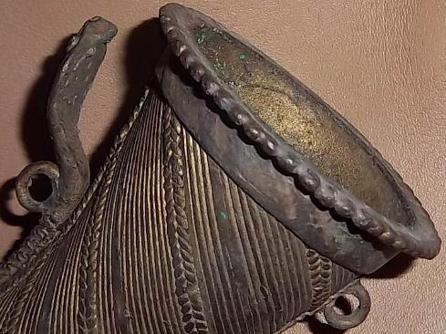

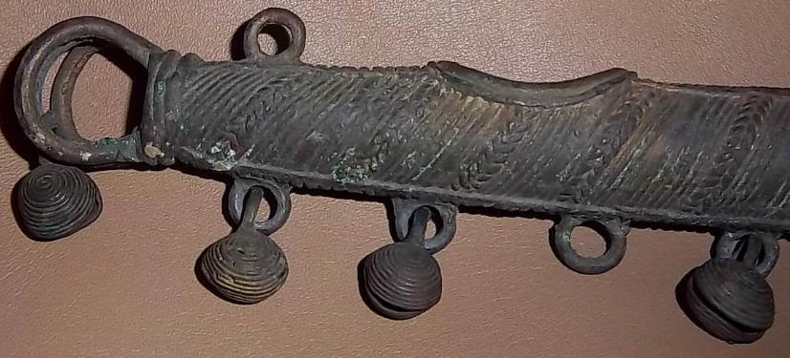 SHAPE \* MERGEFORMAT 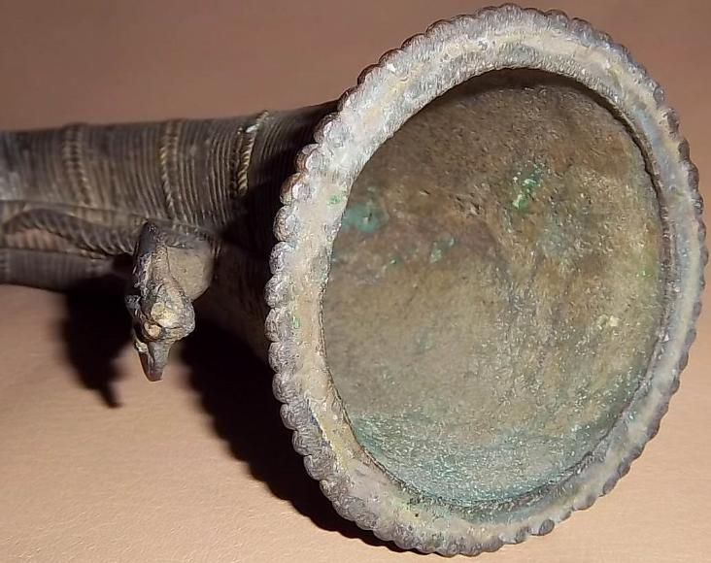

Figs 2-6. Afr-Nigeria-Benin-Edo Peoples-Trumpet with bells-Bronze-19th c-Details

Case No.: 6

**Accession No.**

**Formal Label:** Afr-Nigeria-Benin-Edo Peoples-Trumpet with bells-Bronze-19th c-Details

**Display Description:**

Bronze trumpets such as this were played by royal musicians who would attend the *Oba* as part of his official regal retinue. A trumpet (*erere*) such as this one would be played at a ceremony such as the *Ugie ivie* when someone was about to be beheaded. The *Ugie ivie* was the ceremony when after the *Oba's* royal beads were displayed in the *Oba Ewuare* shrine by the *Iwebo* palace association, a human sacrifice was made in their honor and protection (Bradbury 1957:59; ; Forman, Forman and Dark 1960: 360). The head of the cobra on this trumpet also is suggestive of an apotropaic function.

**LC Classification:** N7397 N5

**Date or Time Horizon: 19th c**

**Geographical Area: Nigeria, Benin**

**Map:**

**GPS coordinates:**

**Cultural Affiliation:**

**Media: bronze**

**Dimensions:**

**Weight:**

**Condition:**

**Provenance:**

**Discussion:**

**References:**

Bradbury, R. E. 1957. *The Benin kingdom and the Edo-speaking peoples of south-western Nigeria*. Ethnographic Survey of Africa, Western Africa: part XIII. London: International African Institute.

Forman, W. and B, and Dark, Philip. 1960. *Benin art*. London: Paul Hamlyn.